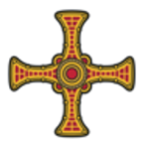
Saint Patrick’s
Roman Catholic Church
Diocese of Hexham and Newcastle
St Patrick’s Presbytery
Goatbeck Terrace,
Langley Moor,
Co. Durham,
DH7 8JJ

APPLICATION FORM
FOR MARRIAGE

Marriage is that sacrament by which a baptised man and woman are bound together by vows to an exclusive lifelong commitment to one another and to accepting and raising children. In this sacrament God gives grace for the fulfilment of these duties. Through the Sacrament of Marriage the mutual love of man and woman becomes a symbol of Christ’s love for his Bride the Church.  To be married in any Catholic church, at least one of the parties must be Catholic, and a non-Catholic partner must be willing to approve of the Catholic party undertaking to do their best to bring up the children of the marriage as Catholics.  Please complete and return this form and hand it to the Priest at Mass. |  |  | 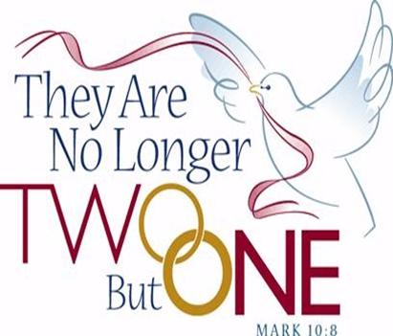
Groom
Name:
Address:

Telephone Number:
Email:
Religion:
Place and Date of Birth: ………………………………………………………….……., …….… / .……… / ……….
Bride
Name:
Address:

Telephone Number:
Email:
Religion:
Place and Date of Birth: ………………………………………………………….……., …….… / .……… / ……….
Proposed Wedding Details
Date:

Time:

Wedding Service / Nuptial Mass (please delete as appropriate)

Organist / Recorded Music (please delete as appropriate)
The organist fee is £75.00p

Permission of Parish Priest (Non-Parishioners)

If you both live outside of the parish, you must obtain the permission of your local Parish Priest before making this application.
Parish: Parish Priest:
I give my permission for the above named to marry outside the parish (Can. 1115).
Signed:

WITNESSES
Name and Address of Best Man: |  | Name and Address of Chief Bridesmaid:
Wedding stipend (Whilst there is no fee for the marriage ceremony, it is traditional to make an offering to the minister which helps with his living expenses. Please consider that this should be at least twice that of the organist fee): £
Information provided in this application, together with all other personal data held about the individuals by the Parish and the Diocese of Hexham and Newcastle, is processed in accordance with the Diocese’s Privacy Notice.
Signed: ……………………………………………………………………………. Date: …………………………………………………………………..
Please sign to confirm that you are aware of the above and approve the retention of the data for this purpose.

For Office Use Only

Initial meeting with the priest (Time/Date)

Marriage Preparation (Time/Date)

Wedding Practice (Time/Date)

Wedding Ceremony (Time/Date)

Wedding Stipend: Y / N | Marriage Schedule: Y / N |  |  | Church Register: Y / N
Organist Fee: Y / N | Schedule Returned Y / N

