Saint Patrick’s
Roman Catholic Church
Diocese of Hexham and Newcastle
St Patrick’s Presbytery
Goatbeck Terrace,
Langley Moor,
Co. Durham,
DH7 8JJ

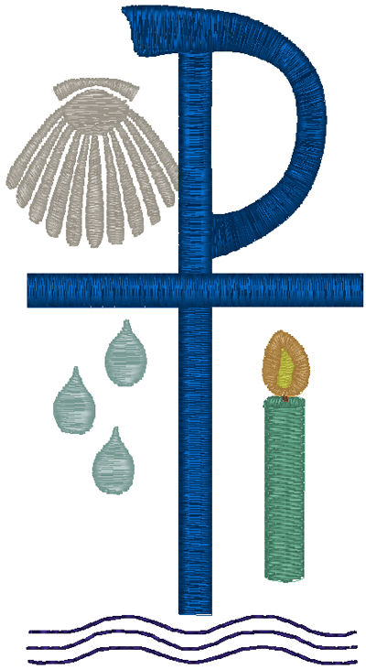
APPLICATION FORM
FOR
INFANT/CHILD BAPTISM

The Sacrament of holy Baptism is the beginning of the whole Christian life, one which is a call to holiness. Baptisms are a regular and essential part of the life of the parish and something we are always very happy to do.
Certain things are necessary to prepare for your child’s baptism:
- Regular attendance (weekly) at Mass
- Attendance at a preparatory session with the Parish Priest
Please complete and return this form and hand it to the Priest at Mass.
Baptismal Name(s) of child:
Surname of child:

Date of Birth: …….… / .……… / ………. Boy / Girl
Parents - Married Y / N
Father: Religion:
Mother: Religion:
Maiden name:
Address:

Post Code:
Telephone Contact Number(s): |  | Email Address(es):
Permission of Parish Priest (Non-Parishioners)

If you live outside of the parish, you must obtain the permission of your local Parish Priest before making this application.
Parish: Parish Priest:
I give my permission for the above infant, who is my parishioner, to be Baptised at Saint Patrick’s Church.
Signed:

GODPARENTS

One godparent, male or female, is sufficient: but there may be more. A godparent must:
- be no less than sixteen years of age;
- be a baptised Catholic who has been confirmed and has received first Eucharist, and who lives a life of faith which befits the role to be undertaken.
Because a godparent is a representative of the Church, standing as a sponsor for the faith, a non-Catholic baptised Christian may not be a godparent, but may stand as a Christian witness in company with a Catholic godparent(s). One who is not baptised cannot stand as a godparent or Christian witness.

Godparents:

Name (Church of Baptism, Address and Year of Baptism Name at Baptism if different now):

Name (Church of Baptism, Address and Year of Baptism Name at Baptism if different now):

Christian Witness:

Name: R.C. Y/N

Name: R.C. Y/N

Baptism stipend (Whilst there is no fee for Baptism it is traditional to make an offering to the minister which helps with his living expenses): £
Information provided in this application, together with all other personal data held about the individuals by the Parish and the Diocese of Hexham and Newcastle, is processed in accordance with the Diocese’s Privacy Notice.
Signed: ……………………………………………………………………………. Date: …………………………………………………………………..
Please sign to confirm that you are aware of the above and approve the retention of the data for this purpose.

For Office Use Only

Preparation Session (Time/Date)

Baptism (Time/Date)

Donation: Y / N | Certificate: Y / N |  | Register: Y / N

